COMP 2601

Tutorial 4

1. Given the following memory values and a one-address machine with an accumulator,

what values do the following instructions load into the accumulator?

Memory Values:

■ Word 20 contains 40.

■ Word 30 contains 50.

■ Word 40 contains 60.

■ Word 50 contains 70.

Instructions:

a. LOAD IMMEDIATE 20

b. LOAD DIRECT 20

c. LOAD INDIRECT 20

d. LOAD IMMEDIATE 30

e. LOAD DIRECT 30

f. LOAD INDIRECT 30

1. An address field in an instruction contains decimal value 14. Where is the corresponding operand located for:

a. immediate addressing?

b. direct addressing?

c. indirect addressing?

d. register addressing?

e. register indirect addressing?

1. Consider a 16-bit processor in which the following appears in main memory, starting

at location 200:

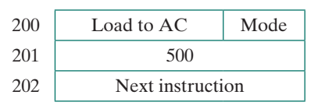

The first part of the first word indicates that this instruction loads a value into an accumulator. The Mode field specifies an addressing mode and, if appropriate, indicates

a source register; assume that when used, the source register is R1, which has a value

of 400. There is also a base register that contains the value 100. The value of 500 in

location 201 may be part of the address calculation. Assume that location 399 contains

the value 999, location 400 contains the value 1000, and so on. Determine the effective

address and the operand to be loaded for the following address modes:

a. Direct

b. Immediate

c. Indirect

d. PC relative

e. Displacement

f. Register

g. Register indirect

h. Autoindexing with increment, using R1

1. A PC-relative mode branch instruction is stored in memory at address -62010. The branch is made to location 53010. The address field in the instruction is 10 bits long.

What is the binary value in the instruction?